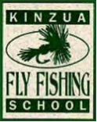

May 18, 2013

“Kinzua Fly Fishing School held at the University of Pittsburgh at Bradford headed by Steve Skvarka and Carl Zandi has been by far the most successful fly fishing school that I have had the privilege to be part of for the past 20 years. It is well organized and comprehensive with all aspects of the game covered, casting instruction, on the stream experience, classrooms lectures, fly fishing knots, and hands on instruction for every student. I am pleased to be part of this school, it has been most enjoyable.”

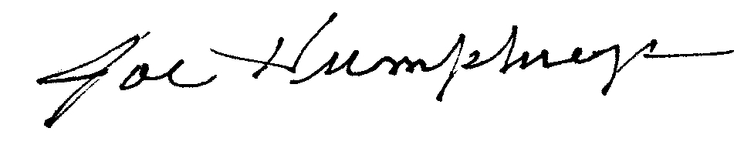

20th Anniversary Kinzua Fly Fishing School

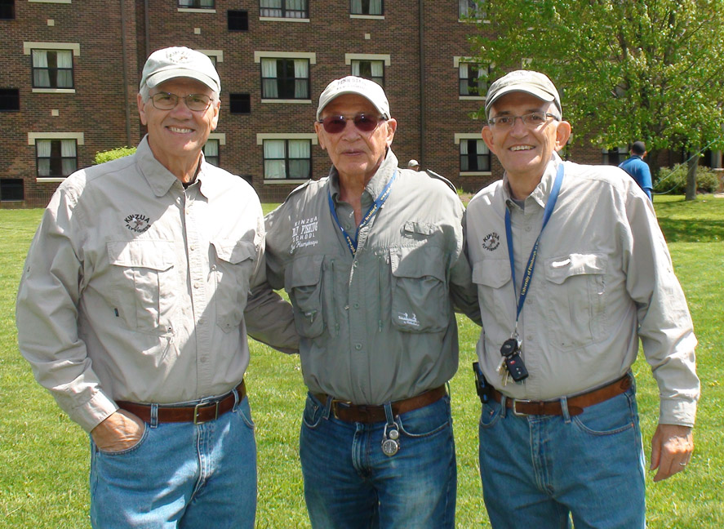
Carl Zandi, Joe Humphreys & Steve Skvarka

